**WALLET App**

**Part 1: Install MetaMask & Set Up Wallet**

**Step 1: Install MetaMask**

1. Go to the official site: <https://metamask.io/>
2. Click **Download** and choose your browser (Chrome, Firefox or Edge).
3. Add the extension to your browser.

OR

1. Open the **App Store/Play Store**
2. Search for **“MetaMask”**
3. Tap **"Install"** or **"Get"**.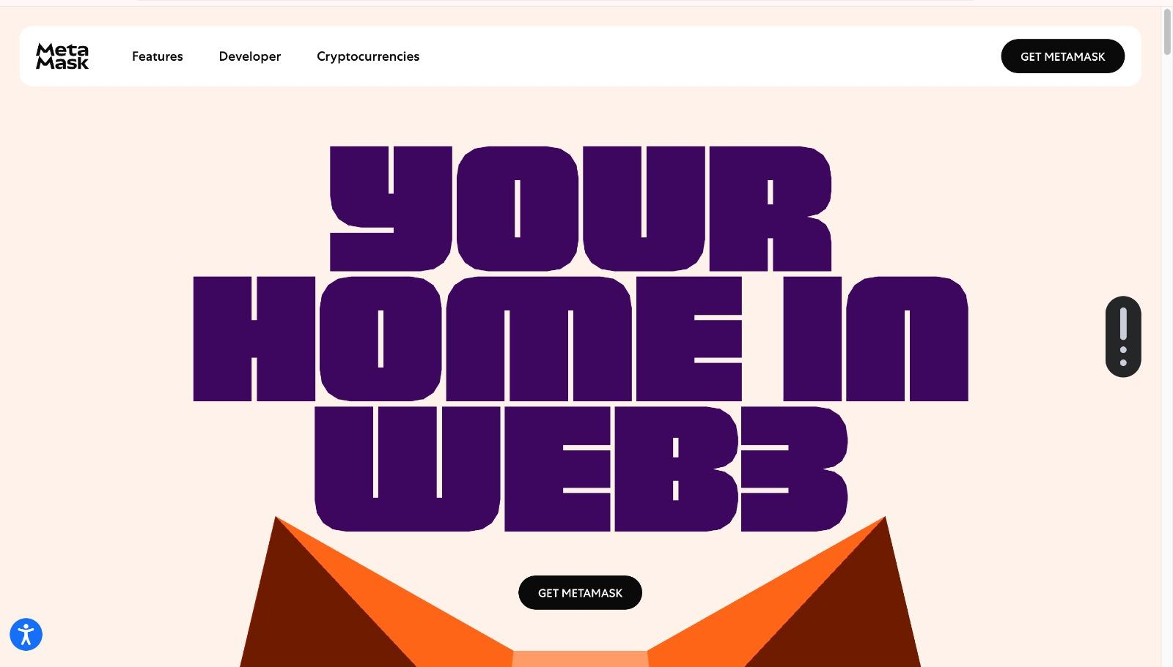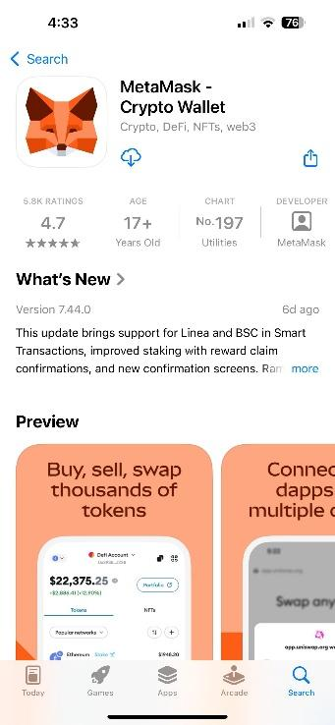

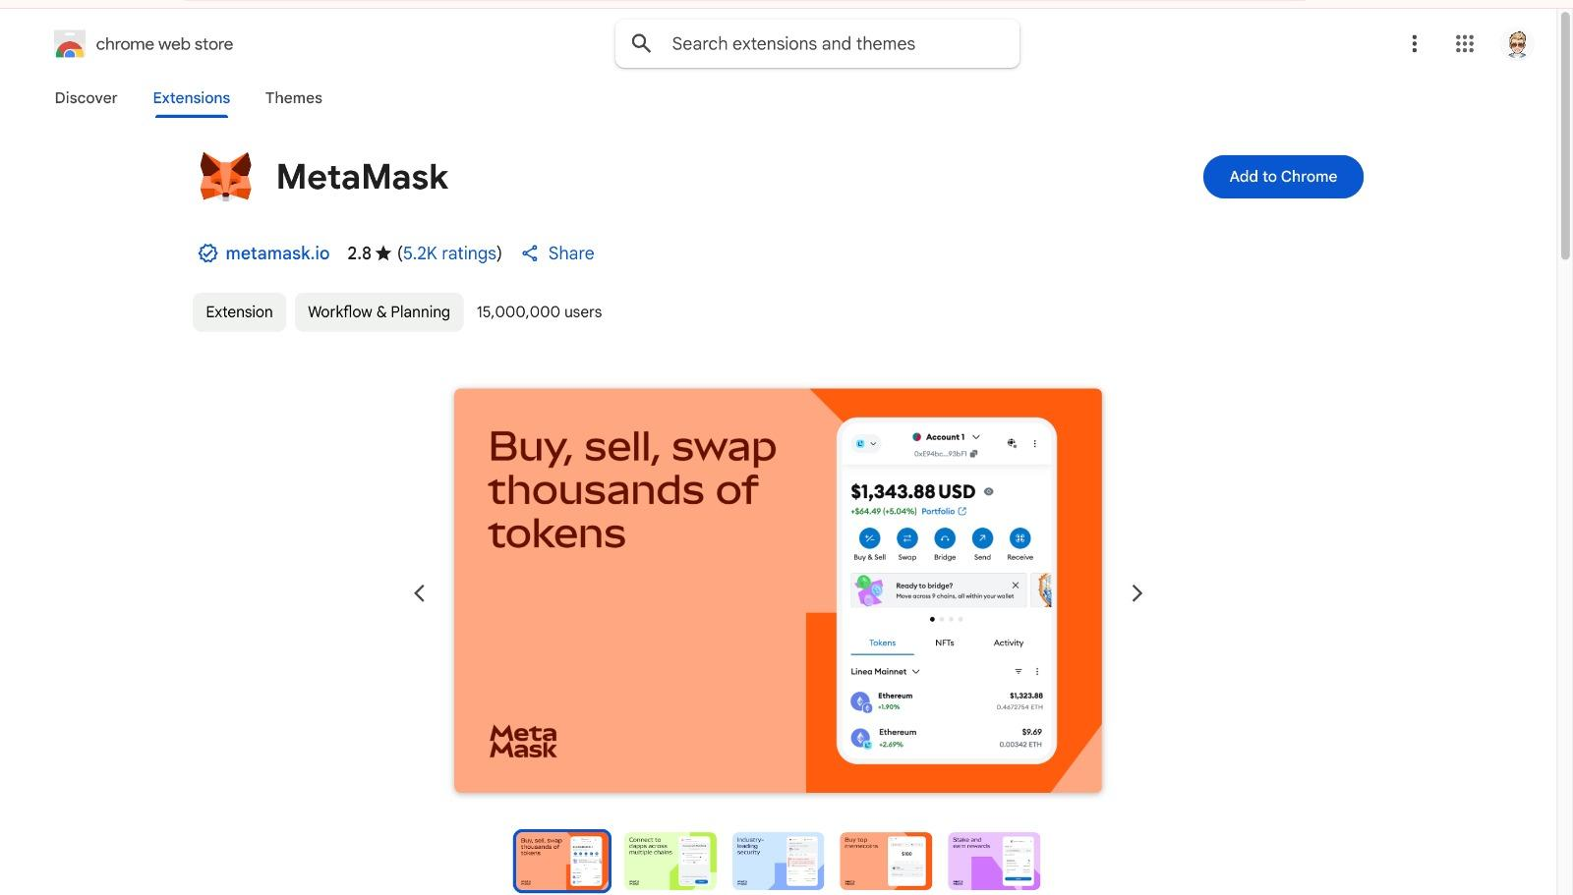

**Step 2: Create or Import a Wallet**

1. Click the MetaMask extension icon.
2. Choose **Create a Wallet** or **Import Wallet** (if you already have one).
3. Follow the setup steps:
   * Set a password.
   * Back up your **Secret Recovery Phrase** securely.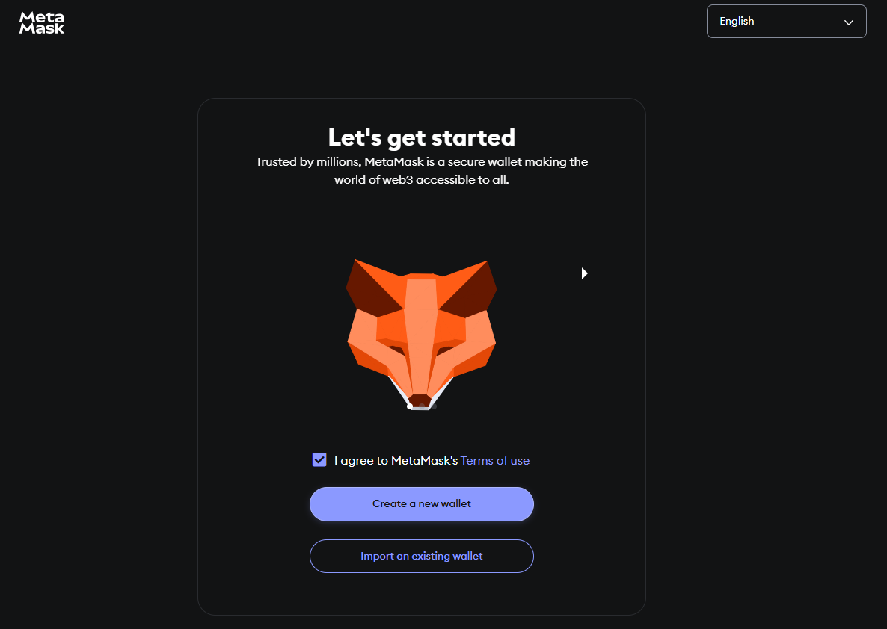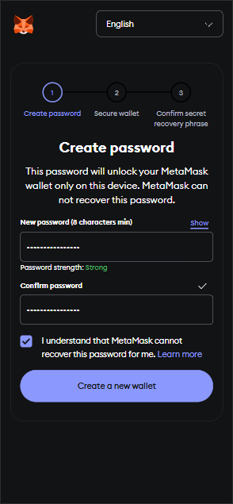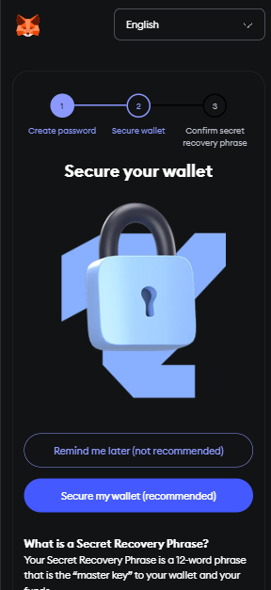

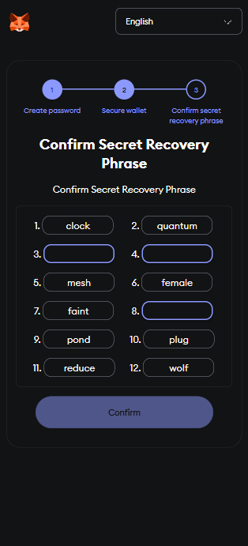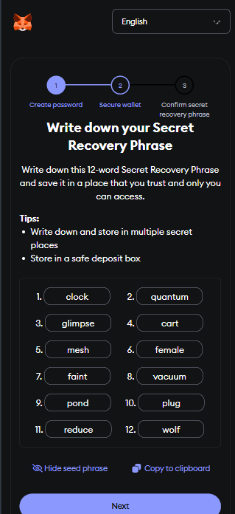

**Step 3: Add a Test Network (Sepolia)**

1. Open MetaMask.
2. Click your account icon > **Settings** > **Networks**.
3. Add a network like **Sepolia**:
4. Get free test ETH from a **faucet**:
   * Sepolia Faucet: [https://cloud.google.com/application/web3/faucet](https://cloud.google.com/application/web3/faucet/ethereum/sepolia)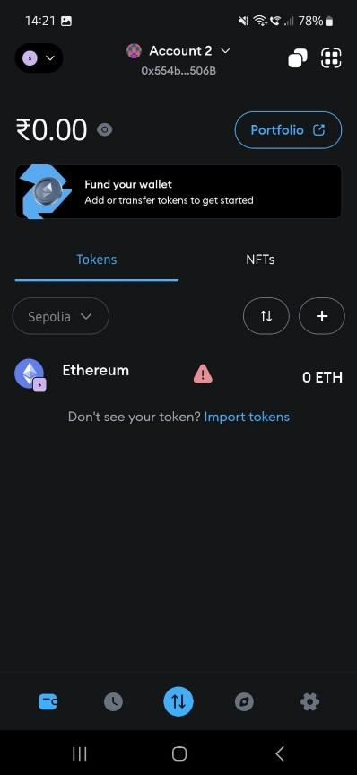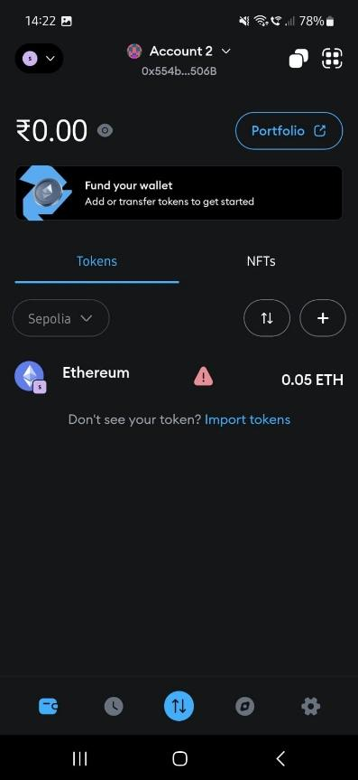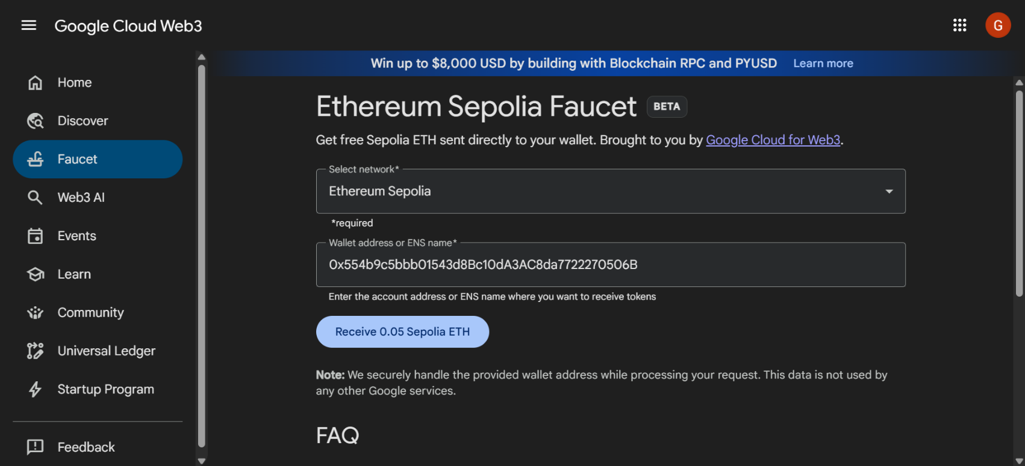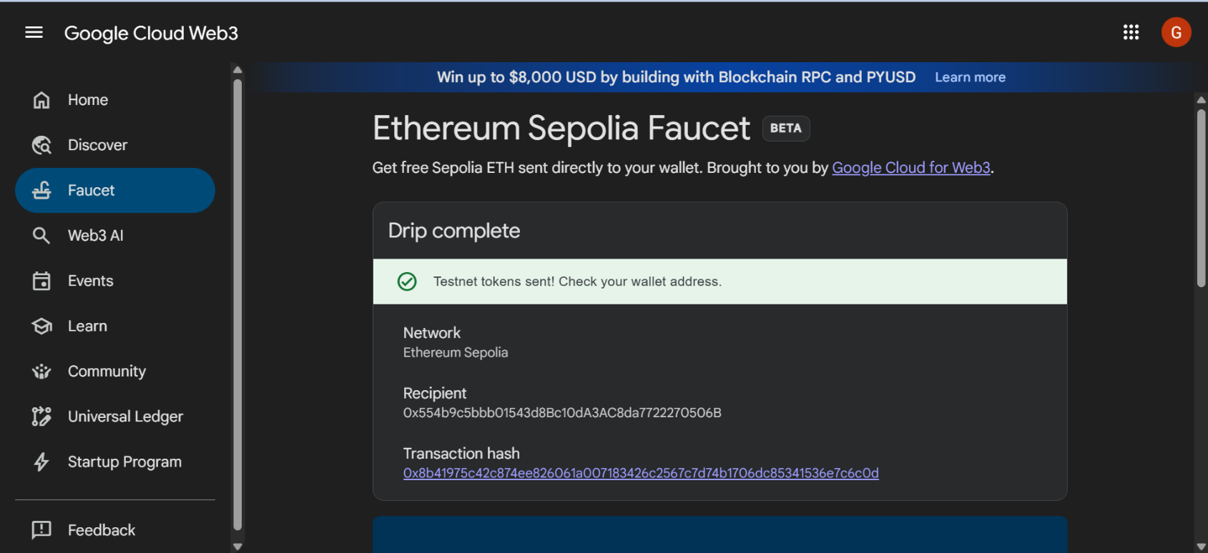

**Part 2: Smart Contract - Ether manager App**

**Step 4: Code for Smart Contract**

// SPDX-License-Identifier: MIT

pragma solidity ^0.8.4;

contract EthWalletManager {

// Event emitted when a transfer occurs

event Transfer(

address indexed sender,

address indexed recipient,

uint256 amount,

uint256 timestamp

);

// Error messages

error InsufficientBalance(uint256 available, uint256 required);

error TransferFailed();

error ZeroAmount();

error ZeroAddressNotAllowed();

function getBalance() public view returns (uint256) {

return address(msg.sender).balance;

}

/**

* @dev Transfers ETH to a specified address

* @param recipient The address to send ETH to

* @param amount The amount of ETH to send in wei

*/

function transferEth(address payable recipient, uint256 amount) public payable {

// Input validation

if (recipient == address(0)) revert ZeroAddressNotAllowed();

if (amount == 0) revert ZeroAmount();

// Check sender's balance

if (address(msg.sender).balance < amount) {

revert InsufficientBalance({

available: address(msg.sender).balance,

required: amount

});

}

// Perform transfer

(bool success, ) = recipient.call{value: amount}("");

if (!success) revert TransferFailed();

// Emit event

emit Transfer(

msg.sender,

recipient,

amount,

block.timestamp

);

}

// Allow the contract to receive ETH

receive() external payable {}

}

**Part 3: Deploy the Contract Using Remix**

**Step 5: Open Remix IDE**

1. Visit [https://remix.ethereum.org](https://remix.ethereum.org/)
2. Create a new file and paste in your EthWalletManager contract code.

**Step 6: Compile the Contract**

1. Go to the **Solidity Compiler** tab.
2. Make sure the version is set to ^0.8.4 or higher.
3. Click **Compile EthWalletManager.sol**. 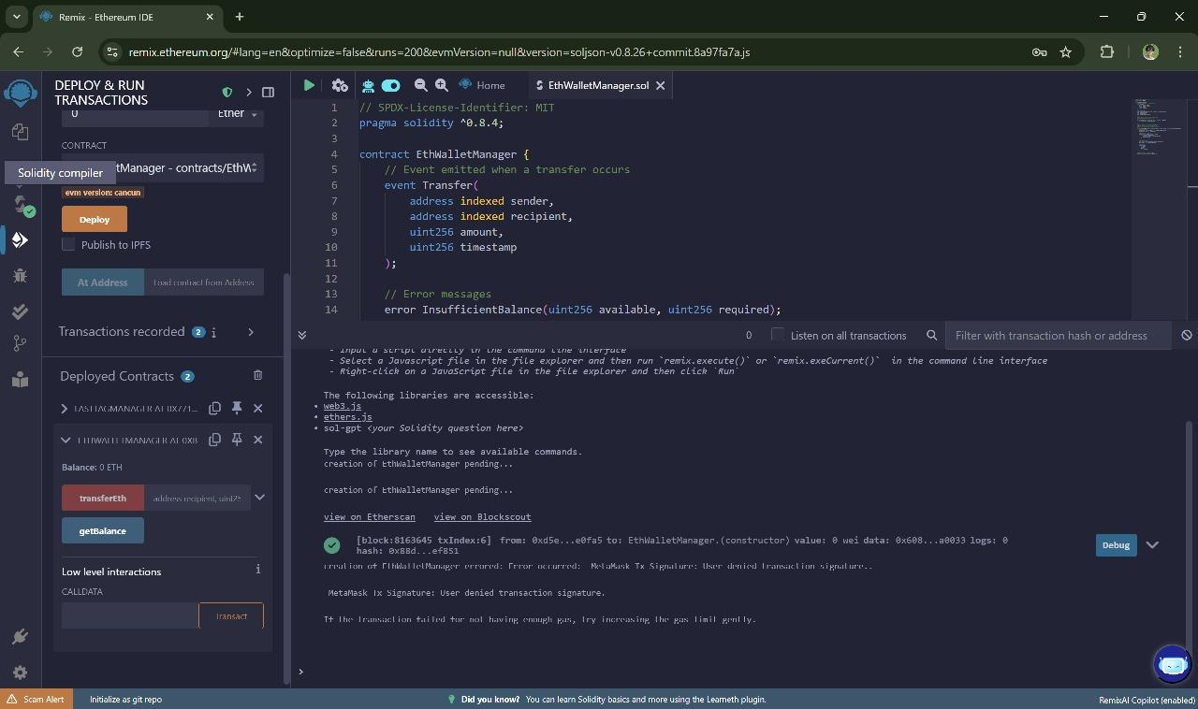

**Step 7: Connect MetaMask to Remix**

1. Go to the **Deploy & Run Transactions** tab.
2. In the **Environment** dropdown, choose **Injected Provider - MetaMask**.
3. MetaMask will pop up — approve the connection to Remix.

**Step 8: Deploy the Contract**

1. Make sure your account has some ETH (from faucet).
2. Click **Deploy**.
3. MetaMask will prompt you to confirm the transaction.
4. Once deployed, your contract address will appear in Remix.

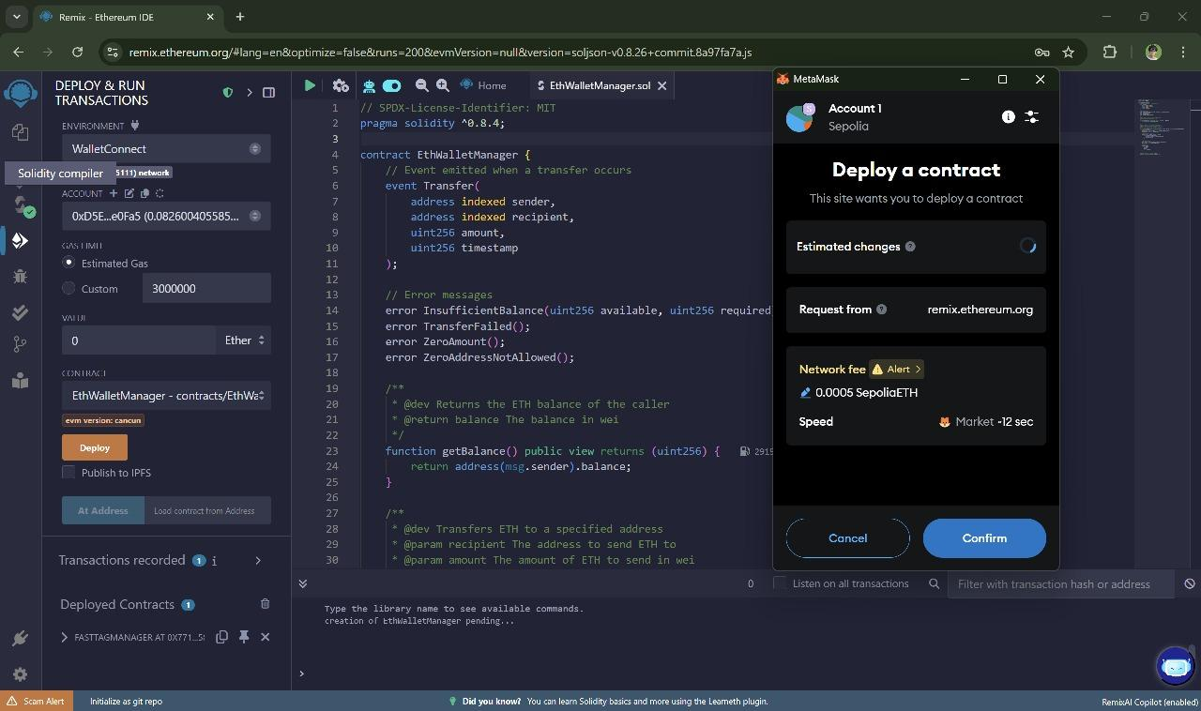

**Part 4: Interact With the Smart Contract**

**Step 9: Use Remix Interface**

1. getBalance(): Calls your wallet’s ETH balance.
2. Enter a **recipient address**.
3. Set an amount in wei (1 ETH = 1e18 wei).
4. Make sure your wallet has enough ETH to cover the transfer.

**Step 10: Interact with the Contract from a Frontend (Flutter)**

1. Connect Your Wallet by Choosing **MetaMask**
2. View Your **Balance** and **Send** or **Receive** ETH
3. Optionally, tap **“View Transactions”** to see recent activity

